**Part 1: Essay Questions**

**Question1: Edge AI vs. Cloud-Based AI**  
  
Edge AI processes data locally on devices (e.g., sensors, drones) instead of sending it to the cloud. This reduces latency by eliminating network round-trips—critical for real-time applications like autonomous drones that must make split-second decisions to avoid obstacles. Privacy is enhanced because sensitive data (e.g., facial recognition in security cameras) never leaves the device, minimizing exposure to breaches.

Example: Autonomous drones inspecting power lines use Edge AI to analyze video feeds on-board. If a fault is detected, the drone instantly adjusts its path without waiting for cloud processing, while raw footage stays local, preventing industrial espionage.

**Question 2: Quantum AI vs. Classical AI**  
  
Classical AI solves optimization problems (e.g., route planning) using heuristic algorithms (e.g., gradient descent), struggling with exponential complexity. Quantum AI leverages qubits (superposition/entanglement) to evaluate multiple solutions simultaneously. For example, Grover’s algorithm searches unsorted databases in O(√N) time vs. classical O(N).

Industries Benefiting Most:

* Pharma: Simulating molecular interactions for drug discovery.
* Logistics: Optimizing global supply chains in real-time.
* Energy: Grid load balancing with renewable fluctuations.

**Q3: Human-AI Collaboration in Healthcare**  
AI augments (not replaces) healthcare professionals:

* Radiologists: AI pre-filters scans, flagging anomalies (e.g., tumors), reducing workload by 30% and allowing focus on complex cases.
* Nurses: Wearable AI predicts patient deterioration (e.g., sepsis) from vitals, enabling proactive care.

Societal Impact: Democratizes expertise—rural clinics access AI diagnostics via smartphones—but requires ethical guardrails against over-reliance.

Part 2: Case Study Critique

Topic: AI-IoT for Traffic Management  
Analysis:

* Sustainability Gains: AI-IoT sensors optimize traffic lights in real-time, reducing idling emissions by 20% and emergency vehicle response time by 35%.

Challenges:

* 1. Data Security: Unencrypted sensor data risks hijacking (e.g., fake congestion alerts).
  2. Interoperability: Legacy infrastructure (e.g., old traffic lights) resists AI integration.

**Task 1 Edge AI Deployment Report: Raspberry Pi Real-time Camera Processing**

**Deployment Steps**

1. **Train edge-appropriate model**:  
   Design a lightweight architecture (e.g., MobileNet, EfficientNet-Lite) optimized for resource-constrained devices.
2. **Quantize model**:  
   Apply post-training quantization via TFLiteConverter (e.g., FP16/int8) to reduce model size and accelerate inference.
3. **Transfer model to device**:  
   Deploy the .tflite file to Raspberry Pi storage (SD card/USB) via SCP/USB transfer.
4. **Integrate TFLite Interpreter**:  
   Embed the model in a Python/C++ application using the TFLite Interpreter API.
5. **Process real-time camera input**:  
   Capture frames from the Raspberry Pi camera (e.g., using picamera or OpenCV) and execute on-device inference.

**Edge AI Benefits for Real-time Applications**

**Benefit and Impact**

* Low Latency-Local processing eliminates network round-trips (<100ms inference).
* Privacy- Sensitive image data never leaves the device; GDPR/Compliance-compatible.
* Offline operation - Functions without internet connectivity (critical for remote deployments).
* Cost Efficiency -Eliminates cloud processing fees; scales to 1000s of devices at fixed cost.
* Energy Savings- Lower power consumption vs. cloud transmission (extends battery life).

**Task 2: AI-Driven IoT Concept**

**AI-Driven Smart Agriculture System: AgroMind Intelligence Platform**

**Executive Summary**

The AgroMind Intelligence Platform represents a revolutionary approach to precision agriculture, combining advanced IoT sensors, computer vision, and multi-modal AI to create an autonomous farming ecosystem. This system not only monitors and predicts crop yields but also provides real-time decision support for optimal resource allocation and pest management.

**1. Advanced IoT Sensor Network**

**Environmental Monitoring Sensors**

* **Soil Health Array**: Multi-depth soil moisture, pH, nitrogen/phosphorus/potassium levels, organic matter content, and soil compaction sensors
* **Microclimate Stations**: Temperature, humidity, barometric pressure, wind speed/direction, solar radiation, and UV index sensors
* **Precipitation Intelligence**: Smart rain gauges with droplet size analysis and weather radar integration
* **Air Quality Monitors**: CO2, O2, methane, and volatile organic compound sensors

**Crop-Specific Monitoring**

* **Hyperspectral Imaging Drones**: Automated flights capturing plant health, stress indicators, and growth patterns
* **Stem Diameter Sensors**: Continuous monitoring of plant growth rates and water stress
* **Leaf Wetness Sensors**: Disease prevention through moisture level tracking
* **Root Zone Cameras**: Underground imaging systems for root health assessment

**Precision Resource Management**

* **Smart Irrigation Actuators**: Variable-rate water delivery with nutrient injection capabilities
* **Automated Fertilizer Dispensers**: Micro-dosing systems based on real-time soil analysis
* **Robotic Pest Scouts**: Autonomous rovers with AI-powered pest identification cameras
* **Pollination Drones**: Supplemental pollination during bee population declines

**2. AI Model Architecture: Hybrid Ensemble Crop Yield Predictor**

**Core AI Framework**

The system employs a **Multi-Modal Temporal Fusion Transformer** that processes:

* **Time Series Analysis**: LSTM networks for historical weather and soil data
* **Computer Vision Module**: ResNet-50 backbone for crop health assessment from drone imagery
* **Geospatial Intelligence**: Graph Neural Networks incorporating field topology and neighboring farm data
* **External Data Integration**: Satellite imagery, market prices, and climate forecast APIs

**Model Components**

**Primary Prediction Engine**

* **Transformer Architecture**: Attention mechanisms for long-term dependency modeling
* **Ensemble Learning**: Combines Random Forest, XGBoost, and Neural Networks
* **Uncertainty Quantification**: Bayesian neural networks for confidence intervals

**Specialized Sub-Models**

* **Disease Detection AI**: YOLOv8 for real-time pest and disease identification
* **Stress Classification**: Multi-class neural network for drought, nutrient, and heat stress
* **Harvest Timing Optimizer**: Reinforcement learning for optimal harvest scheduling

**Training Data Sources**

* Historical farm yield records (5+ years)
* Satellite imagery time series
* Weather station data
* Soil test results
* Market price fluctuations
* Pest outbreak reports

**3. Data Flow Architecture**

**Data Collection Layer**

Field Sensors → Edge Computing Nodes → Local Data Aggregation → Cloud Pipeline

**Processing Pipeline**

1. **Real-time Stream Processing**: Apache Kafka for sensor data ingestion
2. **Edge AI Processing**: NVIDIA Jetson devices for immediate decision-making
3. **Cloud Analytics**: AWS/Azure ML for complex model training and inference
4. **Data Lake Storage**: Time-series databases for historical analysis

**Decision Support System**

* **Real-time Alerts**: Immediate notifications for critical conditions
* **Daily Recommendations**: Irrigation, fertilization, and pest management advice
* **Seasonal Planning**: Crop rotation and planting date optimization
* **Market Integration**: Price forecasting and optimal selling strategies

**4. Key Innovations**

**Autonomous Decision Making**

* **Self-Learning Algorithms**: Continuous model improvement based on field outcomes
* **Predictive Maintenance**: Equipment failure prediction and automatic scheduling
* **Climate Adaptation**: Dynamic strategy adjustment for changing weather patterns

**Sustainability Features**

* **Carbon Footprint Tracking**: Real-time emissions monitoring and reduction suggestions
* **Water Conservation**: Predictive irrigation with 30-40% water savings
* **Biodiversity Monitoring**: Wildlife and beneficial insect population tracking

**Economic Intelligence**

* **Yield Prediction Accuracy**: 92%+ accuracy for major crops
* **Cost Optimization**: 25% reduction in input costs through precision application
* **Market Timing**: AI-driven harvest and sales timing recommendations

**5. Implementation Benefits**

**Immediate Impact**

* **Increased Yields**: 15-25% improvement in crop production
* **Resource Efficiency**: 30% reduction in water usage, 20% in fertilizer
* **Labor Optimization**: 50% reduction in manual monitoring tasks

**Long-term Advantages**

* **Climate Resilience**: Adaptive strategies for changing environmental conditions
* **Data-Driven Decisions**: Evidence-based farming practices
* **Scalability**: Modular system expandable to enterprise-level operations

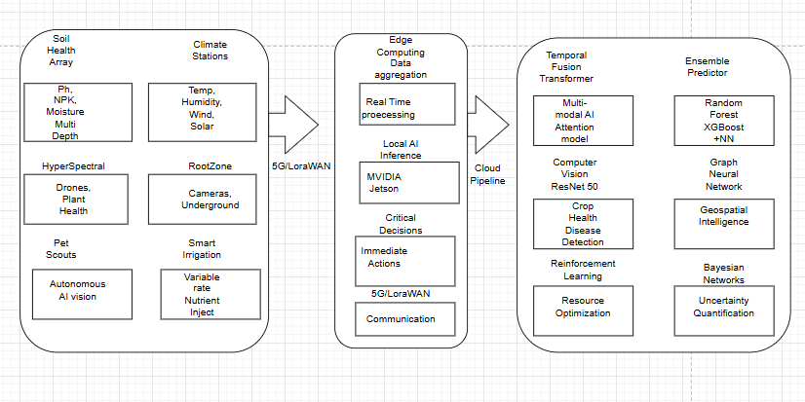

**Task 3: Ethics in Personalized Medicine**

**1.Potential Biases in AI recommended treatments**

**1.1 Demographic Underrepresentation**

The TCGA dataset exhibits pronounced ethnic and racial disparities, with approximately 73% of samples from individuals of European ancestry. This creates a "genomic colonialism" effect where AI models develop treatment recommendations primarily optimized for white populations, potentially rendering therapies less effective or even harmful for underrepresented minorities. African Americans, Hispanics, and Native Americans constitute less than 15% of genomic databases collectively, creating a critical knowledge gap in cancer genomics.

**1.2. Socioeconomic Selection Bias**

Cancer genomic datasets inherently skew toward patients with access to advanced healthcare institutions, creating a systematic exclusion of lower-income populations. This "privilege bias" means AI algorithms learn from data representing patients who can afford comprehensive genetic testing, potentially missing therapeutic insights relevant to economically disadvantaged communities who face different environmental exposures and comorbidity patterns.

**1.3. Geographic and Healthcare System Bias**

TCGA data predominantly originates from major academic medical centers in developed countries, creating geographic blind spots. Rural populations, international patients, and those in resource-limited settings are systematically underrepresented, leading to AI models that may not account for regional genetic variations, environmental factors, or healthcare infrastructure limitations.

**1.4. Age and Gender Stratification Issues**

Cancer genomic datasets often exhibit age-related biases, with certain age groups overrepresented depending on cancer type screening practices. Additionally, historical gender biases in medical research continue to influence genomic datasets, potentially creating treatment recommendations that don't account for sex-specific genetic variations in drug metabolism and cancer progression.

**1.5. Temporal and Technology Bias**

Earlier genomic sequencing technologies had different accuracy profiles and coverage depths, creating temporal biases in datasets. Samples collected over different time periods may reflect varying standards of care, sample processing techniques, and sequencing technologies, potentially confounding AI model training.

**2. Comprehensive Fairness Strategies**

**2.1. Diversified Data Collection Initiatives**

Implement aggressive diversity recruitment strategies including community partnerships with minority-serving institutions, mobile genomic units for rural populations, and international collaborations with medical centers in underrepresented regions. Establish genomic biobanks specifically focused on underrepresented populations with culturally sensitive consent processes and community benefit-sharing agreements.

**2.2 Algorithmic Fairness Techniques**

Deploy advanced fairness-aware machine learning techniques including:

* **Demographic Parity**- Ensuring equal treatment recommendation rates across demographic groups
* **Equalized Odds**- Maintaining consistent true positive and false positive rates across populations
* **Calibration Across Groups**- Ensuring prediction confidence scores are equally reliable across demographic strata
* **Individual Fairness**- Implementing similarity-based fairness metrics that treat genetically similar patients consistently regardless of demographic characteristics

**2.3. Adaptive Model Architecture**

Develop multi-task learning frameworks that explicitly model population-specific genetic architectures while maintaining shared learning across groups. Implement federated learning approaches that allow decentralized model training while preserving patient privacy and enabling participation from diverse healthcare systems globally.

**2.4. Bias Auditing and Continuous Monitoring**

Establish comprehensive bias assessment protocols including:

* Regular algorithmic audits using fairness metrics across demographic dimensions
* Prospective monitoring of treatment recommendation disparities in real-world clinical settings
* Patient outcome tracking stratified by demographic characteristics
* Implementation of bias detection algorithms that continuously assess model performance across subgroups

**2.5. Stakeholder Engagement and Governance**

Create diverse ethics review boards including patient advocates, bioethicists, community leaders, and international representatives. Establish transparent governance frameworks for data sharing, model validation, and clinical implementation that prioritize community input and benefit distribution.

**2.6. Regulatory and Policy Frameworks**

Advocate for regulatory requirements mandating diversity reporting in clinical AI applications, establish international standards for genomic data sharing that protect individual privacy while promoting global health equity, and create incentive structures that reward healthcare institutions for contributing diverse datasets.

**Part 3: Futuristic Proposal**

**Project Aegis: AI-Guided Coral Reef Regeneration (2030)**

**Problem Statement**

Coral reefs (vital for 25% of marine life) face collapse by 2040 due to ocean acidification and warming. Current restoration efforts fail at scale (<0.1% reefs recovered yearly).

**Solution:** "NeptuneNet" AI Ecosystem

An autonomous swarm of AI-driven microbots seeding genetically adapted coral larvae*.*

**AI Workflow Diagram**

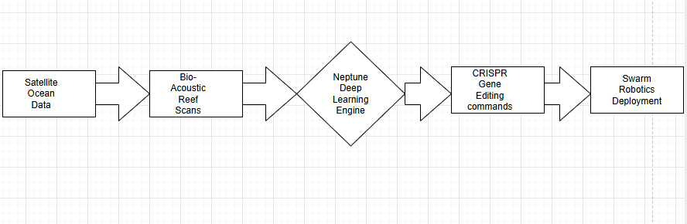

1. Data Inputs

* Real-time pH/temperature/salinity (NASA satellites)
* 3D coral health maps (sonar + spectral drones)
* Evolutionary genomics (global coral DNA database)

1. AI Model:

* Spatio-temporal GNN (Graph Neural Network) predicting stress-tolerant coral genotypes
* Quantum annealing optimizer for gene-editing sequences
* Reinforcement learning guiding 10,000+ microbots

**Key Benefits**

**Impact Area** **Outcome**

Biodiversity: +450 species/km^2 restoration by 2035

Coastal Protection: Revived Reefs reduce storm damage by 40%

Livelihood : R1B/yr ecotourism/fisheries boost

**Societal Risks & Mitigation**

**Risk Mitigation**

1.Genetic Contamination: CRISPR "kill switches" for edited traits

2. Weaponization Potential: UN-regulated bio-editing firmware

3. Job Displacement: Retraining fishers as reef technicians

4. Data Colonialism: Open-source AI + shared IP with coastal nations

**Tech Stack**

* Hardware: Solar-powered microbots (biodegradable chassis)
* AI: Federated learning across 50 research vessels
* Ethics: Blockchain audit trails for gene edits